Blue Raven User’s Guide
USB-centric beta test version 2/14/2023

Introduction
This guide is for an interim version of the Blue Raven embedded software, which supports almost all planned in-flight features, but which currently supports only one Bluetooth interface feature: the ability to update the embedded software over the air (OTA) from iOS or Android phones. OTA updates will enable new features to be added as they become available. These new features will include using the phone to read and update deployment logic, download flight files, read real-time continuity and health status, and more. In the meantime, the USB serial connection is the only available means to perform these actions.

Blue Raven mounting and electrical connections
The size, mounting holes, terminal locations and assignments, and the power interface to the Blue Raven are identical to that of the Raven4. For now, see the Raven user’s manual for instructions and cautions. Be sure to use the correct polarity when applying power. Note that each deployment output channel fires by connecting the output terminal to the ground (Gnd) terminal. This is known as an open-drain circuit and it means that one end of the ematch or igniter must be connected to the + side of the battery, and the other end connected to the Blue Raven terminal. Unlike the previous Ravens, the Blue Raven can be installed in any orientation, including horizontal, or skewed by any amount, and the operation will be unaffected.
[In the future, this section will include all necessary information without referring to the Raven user’s manual]

Beeper and LEDs
The Blue Raven has a red, green, and blue LED, and a beeper to communicate status in addition to the Bluetooth and USB interfaces. At power up, the Blue Raven beeps with a high frequency, low frequency, and then high frequency, pauses and then beeps the input battery voltage rounded down to the nearest volt, one beep per volt. Each high beep is accompanied by a green flash of the LED, and each low beep has a red flash of the LED. After the battery voltage is beeped out, the Blue Raven periodically beeps the status of the voltage input to each channel with a series of 4 beeps, one beep per channel starting with the Apo channel and moving on to the Main, 3rd and 4th channels. A high beep indicates that an ematch or igniter is connected and showing continuity. A low beep indicates that an ematch or igniter is disconnected or failed open. The threshold for continuity detection is 3.8V, which means that the battery supplying the pyro charges needs to have a voltage at least that high for the continuity indications to work.
The blue LED indicates Bluetooth radio activity. The LED flash is initially less frequent to indicate the Bluetooth radio is advertising but not yet connected. After the Bluetooth connection is established, the blue LED flashes more frequently.
The green LED flashes along with the high beeps to indicate that a deployment output is connected.
The red LED flashes along with the low beeps to indicate low/no deployment output continuity voltage. It also turns on when the on-board flash memory is active, for example right after power-up when a previous flight’s data is being erased to make room for a new flight, and during the flight when flight data is being written to flash memory.

Updating the Blue Raven to the latest version of embedded software
The Blue Raven uses a custom phone application on iOS and Android which provides the primary user interface to the Blue Raven, and updates the Blue Raven’s embedded software over the air via its Bluetooth connection.
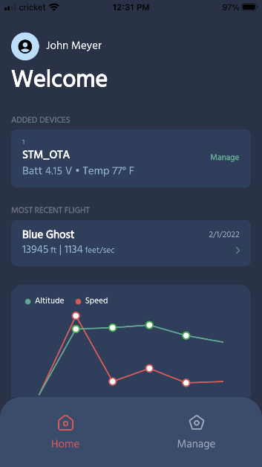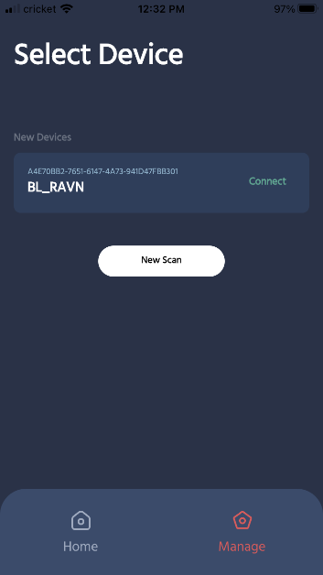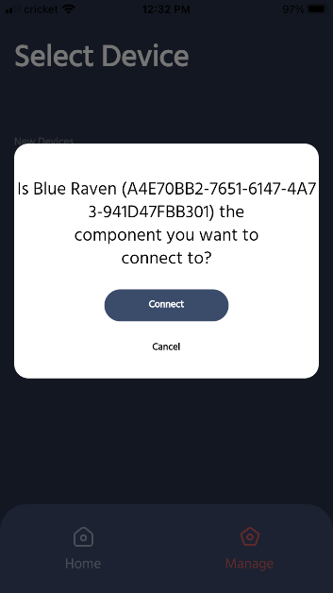
Click the “Manage” icon. Click the “Connect” button Click “Connect”
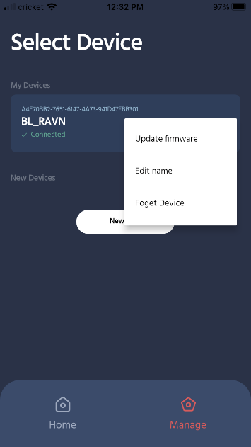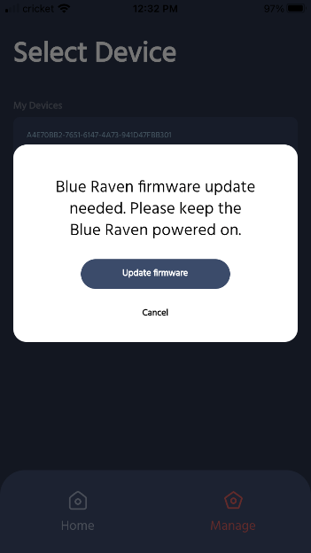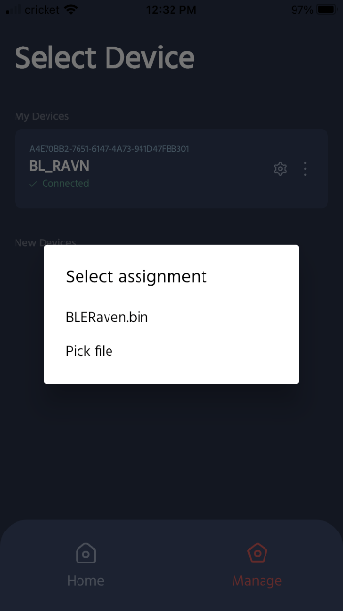
Click the dots and Update Firmware Click Update firmware Select BLERaven.bin

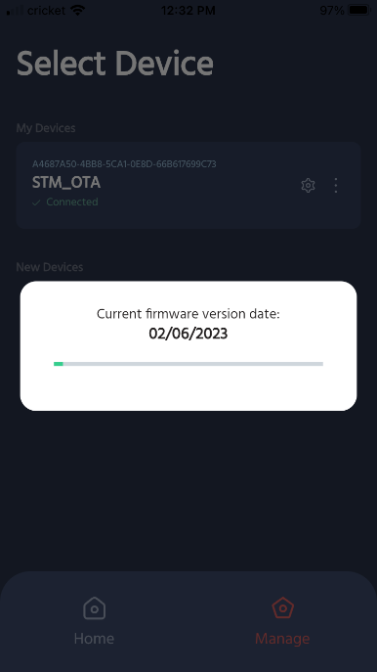
The new firmware will now start loading.
After the new embedded software has finished downloading, the Blue Raven will restart.

Serial connection (required for initial beta testing, optional after Bluetooth phone app integration is complete)
Power up the Blue Raven before connecting a micro-USB cable to your computer. Note that many, if not most, USB micro cables are only for charging and do not have data connections. Use a serial terminal program such as RealTerm or Putty to interact with the Blue Raven. I use RealTerm and any examples/discussion will be based on that program, but others should also work.
The Blue Raven uses STMicro’s Virtual Comm Port (VCP) drivers for the serial connection. Drivers should load automatically the first time you plug in a powered Blue Raven. With the VCP drivers, the baud rate you select in the terminal program is ignored, and data is transferred at USB full speed. There is no parity checking. In RealTerm, go to the port tab, select the port that is used for the Blue Raven (unplug and plug it in to see what port is being used by the Blue Raven)) and click the “open” button. The “open” button toggles between opening and closing the port. In RealTerm, if you unplug while the comm port is open, an error dialog box will pop up that needs to be closed before you can re-open the comm port. Unfortunately, this pop-up dialog box is often hidden behind the main RealTerm window, but you can bring it to the front using the Windows tool tray.

USB Live status message (optional after Bluetooth phone app integration is complete)
When the Blue Raven is powered and working, and connected to the serial program, it will output a live status message 5 times per second. The scrolling message looks like this:
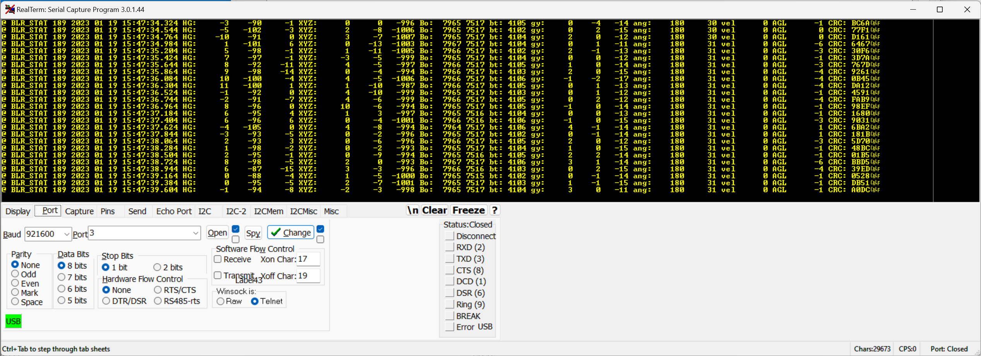
The first field, “@ BLR_STAT” is a message type that you can use for filtering during post-processing. Every output message type has a message-type mnemonic and a time/date stamp. The date stamp currently starts with the build time/date and increments from there. Later, this time/date will be set by the phone over Bluetooth.
The following are basic descriptions of the next fields, with [] indicating that the software puts real values:
HG: [hi-G Accel X Gs x 100][hi-G Accel Y Gs x 100][hi-G Accel Z Gs x 100]
XYZ: [Accel X Gs x1000] [Accel Y Gs x1000] [Accel Z Gs x1000]
Bo: [Baro pressure, atm x10000] [Baro temperature, deg F x100]
bt: [Battery voltage, mV]
gy: [gyro X deg/sec x100] [gyro Y deg/sec x100] [gyro Z deg/sec x100]
ang: [tilt angle, degrees x10] [roll angle, degrees]
vel [vertical velocity from inertial sensors, feet/sec]
AGL [Altitude above ground level from baro sensor, feet]
CRC: [16-bit CRC for the preceding text]
The accelerometer values above have a mild low-pass filter applied. When a calibration is active, the accelerometer values have a much stronger low-pass filter applied.

USB Serial Commands (optional later, required for now)
Commands are sent in RealTerm via the “Send” tab. Enter the text to be sent in the entry box and click the “as ASCII” button to send the string all at once. Typing a command into the terminal window one character at a time is not supported. All of the available commands are described in the following sections. The specific text to send is formatted in <bold courier font>, surrounded by angle brackets that are to be left out. Square brackets indicate numeric values.

Deployment setting introduction and background
Three levels of customization and flexibility are available for the Blue Raven’s deployment settings. 1. The Blue Raven’s default deployment settings provide reliable, fault-tolerant settings right out of the box for most rockets with apogee deployments or apogee/main chute dual deployments. 2. The Blue Raven phone app makes it easy to assign common functions like apogee or main deployments, airstarts or stage separations, with customization options tailored to those functions, such as main chute deployment altitude or airstart maximum tilt angle. 3. Finally, the deployment logic and settings for each of the 4 Blue Raven channels are very customizable with 22 flight options and events to choose from, primary and backup settings, and thresholds for event detection that are user-selected independently for each channel.

Factory Default settings

Apogee Deployments
The Blue Raven default settings assign two outputs for firing a charge at the highest point of the rocket’s flight (apogee). The primary output is assigned to the channel labeled “Apo” on the board, and the channel labeled “3rd” is by default the backup output. Firing a charge at apogee can be used for deploying a parachute for a single-deployment rocket, for separating rocket sections, and/or deploying a smaller drogue chute for a rocket that has dual deployments.
With the default settings for the “Apo” channel, the Blue Raven first checks for motor burnout and then detects apogee based on fault-tolerant apogee detection logic that fires when 2 of 3 independent sensor methods detect apogee. The three sensor votes are barometric pressure increasing (altitude decreasing), gyro-based flight tilt exceeding 90 degrees, and accel-only velocity estimate of less than 0 feet/second.
The default settings on the “3rd” channel are for backup apogee deployments. The Blue Raven checks for barometric pressure increasing, but only when the accelerometer-measured velocity estimate is low enough that transonic or supersonic speeds won’t affect the pressure readings. This is the same logic used in the Raven3 and Raven4 altimeters for the backup apogee.

Lower-altitude dual deployments
For rockets configured for dual deployments, the main chute is deployed at lower altitudes to reduce the drift of the rocket in the wind. The default settings for the channels labeled “Main” and “4th” are for primary and backup main chute deployments, respectively.
The default settings for the “Main” channel will fire after apogee at 700 feet above ground level (AGL). The default settings for the “4th” channel turn on the output during the descent after the apogee channel has fired when altitude falls below a lower threshold of 500 feet AGL. The 4th channel can thus be used as a backup for the main deployment charge, or by itself to deploy the chute at a lower altitude.

Function-based deployment settings with tailored customization
The Blue Raven phone app makes it easy to customize the output channels for your application. Standard output functions like apogee and main chute deployments, stage separation, and motor airstarts can be assigned to any of the four hardware channels on the board. Each function has a setup screen with commonly-adjusted settings that are relevant for that function, for example deployment altitude for the main chute function, or tilt limits for the airstart function.
<Description of phone app screens to be added>

Full customization of deployment logic
With the custom settings option, all of the possible logic settings and thresholds are available for each channel. Each channel has a primary set and a backup set of events that can be checked. When all the selected events of either the primary or the backup set are true, then the channel turns on. The “<” (less than) or “>” (greater than) symbols in the table below show the condition that makes an event true. For example, the AGL1 event becomes true when the altitude is less than 700 feet, and it is false otherwise. All thresholds are checked 50 times per second. Except for the NOMANG and apogee checks, each of the following checks can become true or false each time it is checked, regardless of the previous state. The “nominal ascent” check controlled by the NOMANG threshold is latched for the remainder of the flight after the first time it goes false, and the apogee event is latched true after apogee is detected.
The following events have thresholds that are individually adjustable for each channel:
Event Mnemonic |  | Default Value | Units and typical use case
AGL1 | < | 700 | Feet. Barometric altitude for main chute deployment
AGL2 | > | 1000 | Feet. Barometric altitude for altitude-based staging ignition
FANG1 | < | 7.0 | Degrees. Max allowable current tilt angle
FANG2 | > | 12.0 | Degrees. Trigger an output when FANG2 angle is exceeded
FUTANG | > | 15.0 | Degrees. Future (+3 sec) expected tilt trigger
NOMANG | < | 60.0 | Degrees. Maximum tilt angle for nominal ascent. Latched when false.
Tval1 | < | 2.5 | Seconds. Inhibit output after time delay
Tval2 | > | 5.0 | Seconds. Enable output after time delay
Vel1 | < | 400 | Feet/sec. Transonic inhibit to avoid barometric glitches
Vel2 | > | 300 | Feet/sec. Inhibit stage ignition if going too slowly
Bvel1 | < | -200 | Feet/sec. Baro upward velocity. Early main deployment if apogee charge fails and rocket is falling too fast. Threshold is automatically adjusted proportional to barometric pressure to account for lower density at high altitudes
BURNCOUNT | > | 1 | The burnout count increments each time a positive change in velocity of at least 40 feet/second has occurred followed by a deceleration of at least 5 feet per second. This can be used to gate events after a configurable number of stage burns are complete. This is necessary for a 3rd stage staging/ignition logic to be distinct from 2nd stage staging logic

Three other options apply for each channel:
Option | Option type | Description with default values and use cases
latch | True/False | Default false. When true, if the output is turned on, it will stay on until landing is detected. When false, the output will be on for 1.0 seconds. (latch option planned not yet implemented)
Delay | [number of milliseconds] | Milliseconds. (Default is 1500.) The output countdown delay timer starts after the checked events are true. When the timer expires the output will fire regardless of whether the checked events are still true.
Manual arm | True/False | When false (default for deployments), the channel is enabled at power up. When true, the channel will not fire in flight unless a manual software arming step has taken place pre-launch (default for airstarts)
In addition to the channel-specific events shown above, there are rocket-level flight events that can also be part of any channel’s deployment logic.
Rocket Event | Event description and use cases
Liftoff Detected | Always required before any deployment.
Apogee Detected | This fault-tolerant event detection is latched true when 2 of 3 sensor evaluations detect apogee: Baro pressure increasing, total velocity is < 0, Gyro-based tilt angle > 90. This event is checked for the default apogee and main deployment logic, and is latched true for the rest of the flight.
Pressure Increasing | A version of the barometric pressure with a strong low-pass filter (slow changing) is used to detect when the rocket is encountering increasing atmospheric pressure (i.e. descending). This event is checked in the 3rd channel’s default deployment logic.
Apo channel fired | This event turns true 1.5 seconds after the apogee deployment channel first turns on. This is a check to ensure that any transient events associated with the apogee deployment are complete. This check is used for the default main deployment primary set of checks.
Main channel fired | Similar to the Apo channel fired, but for the Main channel.
3rd channel fired | Similar to the Apo channel fired, but for the 3rd channel.
4th channel fired | Similar to the Apo channel fired, but for the 4th channel.

Deployment options selectable via USB command
Though the Bluetooth interface will provide complete control over the deployment logic settings, including which events are checked, and the thresholds for the checks, the USB interface currently only supports selection of 4 pre-canned options with the following commands: <default>, <2nd stage>, <sustainer>, and <3 stage sim>. After the command is sent, the settings are modified if necessary and stored in flash memory. Then the flash is read back and a hexadecimal representation of which events are checked is displayed. The status is paused for 5 seconds. The current deployment settings can be displayed by sending the command <get deploy>.

The following tables show which events are checked and what the thresholds are for the four selectable options:

Default deployment configuration (<default> command):
 | Unit | Apo | Apo bkp | Main | Main bkp | 3rd | 3rd bkp | 4th | 4th bkp
Channel Events
AGL < AGL1 | feet |  |  | <700 |  |  |  | <500 | <500
AGL > AGL2 | feet
Flight angle < FANG1 | deg
Flight angle > FANG2 | deg
Future Angle > FUTANG | deg
Time < TVAL1 | sec
Time > TVAL2 | sec
Total Velocity < VEL1 | ft/sec |  |  |  |  | <400 | <400
Total Velocity > VEL2 | ft/sec
Baro velocity < BVEL | ft/sec |  |  |  | <-200
Burnout counter > BURNCOUNT |  | >=1 | >=1 | >=1 | >=1 | >=1 | >=1 | >=1 | >=1
Channel is armed |  | Check | Check | Check | Check | Check | Check | Check | Check
Flight Event Register (FER)
Liftoff detected |  | Check | Check | Check | Check | Check | Check | Check | Check
Apogee detected |  | Check | Check | Check | Check
Pressure Increasing |  |  |  |  |  | Check | Check
Burnout Coast
Apo Fired |  |  |  | Check |  |  |  | Check | Check
Main Fired
3rd Fired
4th Fired

Sustainer (<sustainer> command):
Function |  |  |  |  | Airstart, angle-limited |  | Airstart near-vertical
 | Apo | Apo bkp | Main | Main bkp | 3rd | 3rd bkp | 4th | 4th bkp
Channel Events
AGL < AGL1 |  |  | <700 | <700
AGL > AGL2 |  |  |  |  | >600 | >600 | >600 | >600
Flight angle < FANG1 |  |  |  |  | <18 | <18 | <15 | <15
Flight angle > FANG2
Future Angle > FUTANG |  |  |  |  | >12 | >12
Time < TVAL1
Time > TVAL2
Total Velocity < VEL1 |  |  |  |  | <800 | <800 | <460 | <460
Total Velocity > VEL2
Baro velocity < BVEL
Burnout counter > BURNCOUNT | >=1 | >=1 | >=1 | >=1 | >=1 | >=1 | >=1 | >=1
Channel is armed | Check | Check | Check | Check | Check | Check | Check | Check
Flight Event Register (FER)
Liftoff detected | Check | Check | Check | Check | Check | Check | Check | Check
Apogee detected | Check | Check | Check | Check
Pressure Increasing
Burnout Coast
Apo Fired |  |  | Check
Main Fired
3rd Fired
4th Fired
This set of deployment options above is intended for the 2nd stage of a 2-stage rocket. The Apogee and Main deployments are not modified from the defaults. The airstart is intended to be delayed until either the speed is low enough to approach the optimal ignition velocity, or the angle gets high enough to be a problem for downrange distance. See discussion and analysis in the Rocketry Forum. For the sustainer of a 3-stage rocket, the burncount would need to be increased to >=2.

2nd stage of 3-stage flight (<2nd stage> command):
Function |  |  | Airstart 2nd stage |  | 2nd/3rd Separation |  | Airstart near vert
 | Apo | Apo bkp | Main | Main bkp | 3rd | 3rd bkp | 4th | 4th bkp
Channel Events
AGL < AGL1
AGL > AGL2 |  |  | Check | Check |  |  | Check | Check
Flight angle < FANG1 |  |  | Check | Check |  |  | Check | Check
Flight angle > FANG2
Future Angle > FUTANG |  |  | Check | Check
Time < TVAL1
Time > TVAL2
Total Velocity < VEL1 |  |  | Check | Check |  |  | Check | Check
Total Velocity > VEL2
Baro velocity < BVEL
Burnout counter > BURNCOUNT | >=1 | >=1 | >=1 | >=1 | >=2 | >=1 | >=1 | >=1
Channel is armed | Check | Check | Check | Check | Check | Check | Check | Check
Flight Event Register (FER)
Liftoff detected | Check | Check | Check | Check | Check | Check | Check | Check
Apogee detected | Check | Check | Check | Check
Pressure Increasing
Burnout Coast
Apo Fired |  |  | Check
Main Fired
3rd Fired
4th Fired
This set of deployment options above is intended for the 2nd stage of a 3-stage rocket. The Apogee channel is set to deploy a parachute at 2nd stage apogee. The airstart is intended to be delayed until either the speed is low enough to approach the optimal ignition velocity, or the angle gets high enough to be a problem for downrange distance. See discussion and analysis in the Rocketry Forum. The 3rd channel is assigned to fire a stage separation charge immediately after the second stage burnout.

Flight Simulation
The Blue Raven flight simulation capability verifies that deployment settings work as expected before a real flight, and familiarizes the user with the Blue Raven’s flight data recording and analysis features. While the Blue Raven is sitting on the ground, a simulated flight will make the Blue Raven behave just as if it is flying through all the flight dynamics it would experience in a real flight. The Blue Raven will react by turning on the real output channels under the conditions it would during the flight, and the flight data is recorded just as it would be in a real flight to let the user review the deployment events and the conditions that triggered them. Events that are driven by Blue Raven outputs that affect a real flight’s dynamics, including apogee deployment, main chute deployment, and 2nd and 3rd stage motor airstarts can also be simulated and triggered by the real output deployment settings of any of the output channels. Physical effects such as launch angle, atmospheric density changing with altitude, aerodynamic drag, and rocket configuration changes are included in the simulation so that the deployment logic can be fully tested.

Phone App Simulation Interface
(A description of the phone screens and interface will go here)

USB Serial simulation interface (optional)
All of the parameters that specify the simulation options are included in one long command, as shown below for a short single-stage flight with default deployment settings:
- 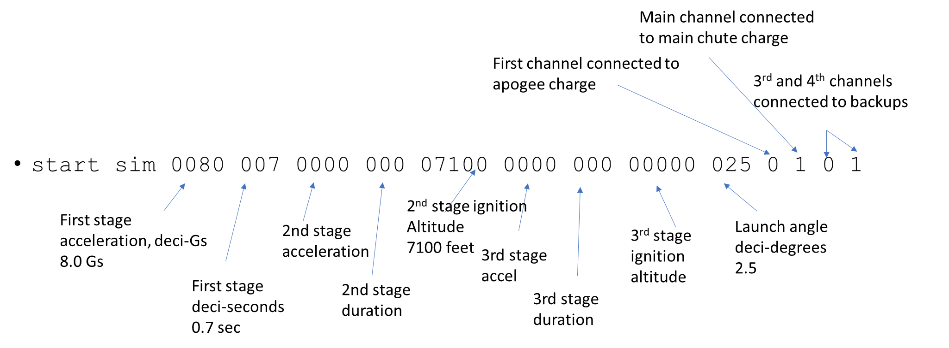
The command has a fixed length and each of the parameters must be located at the fixed positions as shown above. This example command is also provided as text below so that it can be copied from this manual and pasted into the serial terminal:
start sim 0080 010 0000 000 07100 0000 000 00002 025 0 1 0 1
Each of up to three burns are described with 2 parameters: acceleration and burn duration. Motors that are not present are specified with zeroes for acceleration and duration.
Airstarts in second and third stages can be triggered at a fixed altitude parameter in the sim command, or by connecting the virtual motor to an actual deployment output using the last four parameters.
The last 4 parameters use a code for each output to tell the simulation what events should happen when the output fires during the flight. The codes are:
Code | Simulated event
0 | Increase the simulated drag to be consistent with a small drogue chute
1 | Increase the simulated drag to be consistent with a deployed main chute
2 | Ignite a simulated second stage motor
3 | Ignite a simulated third stage motor
9 | No connection
The four codes correspond to the 4 output channels, Apo, Main, 3rd and 4th respectively. Note that a simulation event can be connected to multiple channels. In the example above, this is used to connect both the Apo and 3rd channels to the simulated apogee deployment, and the Main and 4th channels to the simulated main chute deployment. Another use case is to connect an airstart to two output channels in parallel so that different combinations of conditions could be used to start the motor.

Other Simulation Notes
The simulated flight dynamics are added onto the actual measurements made by the accelerometers and gyros during the flight, so be sure to keep the Blue Raven still during the simulation to prevent changes in tilt orientation which would cause unexpected behavior in the simulation.

Changing the Blue Raven operating mode
The Blue Raven powers up into prelaunch mode, which makes the Blue Raven ready for launch. The status of the deployment connections is beeped out, and the accelerometer and gyro pad offsets are periodically updated. The command <checkout> puts the Blue Raven into a mode where the beeps are turned off and the pad offsets are zeroed so that the accelerometer calibration can be observed. The command <prelaunch> puts the Blue Raven back into prelaunch mode, and ready for launch as long as a simulation has not yet been run since the last power cycle.
The other modes, liftoff and landed, happen automatically after liftoff conditions are detected in prelaunch mode, and after landing is detected while in liftoff mode. A power cycle is necessary after a simulated or actual flight before the next flight, to ensure that that all internal states are reset correctly. The mode commands are planned to be accessible only through the USB connection, to avoid the possibility of an accidental launch while the Blue Raven is in checkout mode.

Accelerometer Calibration
The Blue Raven has 3-axis accelerometers that can be re-calibrated by the user to compensate for sensor calibration drift that can occur over time. Re-calibrating within a few days prior to launch is recommended for best inertial navigation performance, but is not necessary for general purpose deployment control.
To calibrate the accelerometers via the USB connection, start with the command <cal start>. The low-pass filtering of the accelerometer data is increased so that small changes can be observed. Next, position the Blue Raven with any of the edges aligned vertically. One axis of the low-range accelerometer should be near 1.0 or -1.0 Gs, while the other axes should be near zero. When the values match this condition, send the command <cal axis>. This records the filtered accelerometer values at the time the command was sent. Next, reposition the Blue raven into another of the 6 positions and repeat the command. The order of the orientations does not matter because the Blue Raven identifies which axis is up. Once all 6 orientations have been recorded, command <cal stop>. If all 6 orientation recordings are valid, the Blue Raven will respond with a message that the new calibration is complete. If the number of positions with valid readings is less than 6 when cal stop is commanded, the calibration attempt is rejected and will need to be started over. Any calibration axis can be redone during the calibration before <cal stop> is commanded.

Flight Data Recording and Post-Flight Downloads
The Blue Raven records three sets of data for each flight:
1. Flight summary data such as maximum altitude and speed
2. Low rate data, which includes a large number of measurements recorded at 50 Hz
3. High Rate data, which includes a smaller set of measurements recorded at 500 Hz.
There is flash memory space in the Blue Raven for two flights. If there is no free space available when the unit is powered up, the oldest flight data is erased.
All three sets of data are downloaded automatically over Bluetooth once the flyer gets back in range of the rocket after the flight. (This capability is planned but not yet implemented.) The summary data is downloaded first so that the flight performance is immediately available for review while the other data sets are downloaded in the background. This can take several minutes.

Phone interface to downloaded data
(to be added)

Summary data via the optional USB interface
To download the most recent flight summary, the command is <summary>. An example of summary data output following the example simulated flight is shown below:

@ SUMMARY 706

Rocket: Adrian's BRav

Build: 02/14/2023 11:19:58000

Launch: 02/14/2023 11:23:31920

landing time: 11:24:14680

pad accel: -220 -34 -9868 mag: 0

rail_direction: -721 -34 -9973

accel pad offsets: 2 0 116

hi-g pad offsets: 8867 7824 9333

flash active: B1 compl: B1 last_hr: 7A900 last_lr: 503F00

apogee h_vel: 22

max motor accel: 80

max drag accel: 1

drogue vel@main: -924

main_avg_vel: 256

burnout_tilt: 44

tilt_efficiency: 931

ascent roll ang: 26

pad_ASL: 6806

max deploy accel: 0 154 2 9

max landing accel: 398

max alt: 897 max vel: 228 CRC: 6FA7

Summary value interpretation

Rocket: Adrian's BRav
The first line is the user-defined name, up to 13 characters. Name is set with <set name [name]> command.

Build: 02/14/2023 11:19:58000

Launch: 02/14/2023 11:23:31920

landing time: 11:24:14680
The next line of the summary is the build date and time of the firmware that’s on the Blue Raven. Next are the launch and landing date and times.

pad accel: -220 -34 -9868 mag: 0

rail_direction: -721 -34 -9973
The pad accel is the measurement of the accelerometers while the rocket was sitting still, in units of Gs x 10,000. The rail direction is the direction of the first motion of the launch, in the sensor coordinate frame, normalized to a vector magnitude of 10,000. This rail direction is assumed to be aligned with the axis of the rocket, and is what is compared to the direction of gravity when calculating the rocket tilt.

accel pad offsets: 2 0 116

hi-g pad offsets: 8867 7824 9333
On the pad, the Blue Raven knows what the magnitude of gravity is supposed to be, and if it measures a pad acceleration that has a slightly different magnitude, it uses that difference to adjust the accelerometer offset values in the direction of the measured gravity direction. The pad offsets for both the low-range and hi-range accelerometers are displayed in units of Gs x 10,000. In the example case, the low-range accelerometer’s z-axis value was adjusted by 0.0116 Gs based on the on-pad measurements, while the Hi-G z-axis value was adjusted by 0.933 Gs.

flash active: B1 compl: B1 last_hr: 7A900 last_lr: 503F00
The next line of the summary displays flash memory status which can be ignored by most users. The first part shows which of the two flash banks are active and which has the most recent completed data (B1 or B2 for bank 1 or bank 2). The last recorded flash address of the flight for the low-rate and high-rate data sets is given next.

apogee h_vel: 22
Apogee h-vel gives the estimated horizontal velocity at apogee, in feet/second.

max motor accel: 80

max drag accel: 1
Max motor accel is the maximum acceleration measured between liftoff and motor burnout, given in units of Gs x10. In the example the max acceleration during the motor burn is 8.0 Gs. Max drag accel is the maximum measured acceleration between motor burnout and apogee, also given in units of Gs x 10. In the example, the max drag acceleration is 0.1 Gs.
drogue vel@main: -924
main_avg_vel: 264
The drogue vel@main is the estimated velocity of the rocket just before main deployment, based on the barometric sensor. It is shown in units of feet/second x 10. In the example the velocity is 92.4 ft/second downward. The main_avg_vel statistic is calculated as the average barometric velocity during a 5-second period, 6 seconds after main deployment. It is shown in feet/second x 10. In the example, the avg main velocity is 26.4 feet/second.

burnout_tilt: 44

tilt_efficiency: 931

ascent roll ang: 26
The burnout tilt is the rocket tilt at burnout, shown in degrees x 10. In the example, the tilt at burnout is 4.4 degrees. The tilt efficiency is a ratio of the vertical velocity at motor burnout compared to an estimate of what it would have been if the flight were perfectly vertical. In this example, the tilt efficiency is 93.1%. The roll angle prior to apogee was 26 degrees (with a manual roll movement during the sim

pad_ASL: 6806
The pad ASL is the altitude above sea level, in feet, based on the barometric pressure. Simulated flights start from the measured altitude of the actual unit at the start of the sim. In this example, the sim was started in the suburbs of Denver with an altitude of 6806 feet.
max deploy accel: 0 154 2 9
The max deployment accelerations are the maximum accelerations measured during the 1-second firing of each of the four deployment outputs, displayed in units of Gs x10. This measurement is taken 500 times per second. For real flights, the maximum acceleration during the 1-second firing could come from the deployment charge itself, or from aerodynamic changes immediately after the charge goes off. In the case of the simulation, the only source of acceleration is the aerodynamic drag. In this example, the simulation had 0 Gs of acceleration during the apogee deployment, 15.4 Gs after the main deployment due to the increased drag from the simulated main chute, 0.2 Gs during the apogee backup event, and 0.9 G during the main backup event.

max landing accel: 398
The max landing accel is based on the highest recorded acceleration in the 10 seconds prior to landing detection. The units are Gs x10, so in this example the landing Gs were 39.8. The landing Gs are simulated by assuming that all simulated vertical velocity is taken out with an impulse spread over one 20 msec simulation cycle.
max alt: 897 max vel: 228 CRC: 50E5
The last line of the summary displays the apogee altitude in feet, and the maximum velocity in feet/second. In this example the max altitude was 897 feet and the max velocity was 228 feet/second.

Downloading flight data

Downloading with RealTerm
Data sent to the terminal window can be saved using the interface under the “Capture” tab. In RealTerm, file names cannot have spaces. Enabling “Direct Capture” and “Display” are recommended.

Low Rate Data
The command for downloading the low-rate data is <download l>. The format of the downloaded data starts with the mnemonic @ LOG_LOW followed by the length of the string, and the time and date of the flight in [year] [month] [day] [hour] [minute] [second] format. The next fields have the flight data as shown below:
[sync code] Bo: [temperature from baro sensor] [pressure in atm x 50,000]
V: [Battery mV] [Apo mV] [Main mV] [3rd mV] [4th mV] [output current, mA]
Vel: [Upward velocity ft/sec] [Down-range ft/sec] [Cross-range ft/sec]
Pos: [Inertial Nav Altitude (ft)][Down-range feet][Cross-range feet]
ang: [tilt angle, deg x10][roll angle, deg][future tilt angle, degx10]
FER: [flight event register code][Apo FER] [Main FER] [3rd FER] [4th FER]
CRC: [16b Buypass CRC code for line of text]

The sync code is a millisecond counter recorded in both the low-rate and high-rate data so that the two data sets can be aligned with each other. The sync code rolls over every 250 msec. The velocity and position data are given in ground-relative inertial coordinates (rather than rocket axes), which is possible due to the rocket attitude propagation performed on-board using the gyro measurements. These measurements are only reasonably accurate as long as the rocket experiences rotation rates within the measurement range of the gyros (+/- 2000 deg/sec). If the rocket has rates beyond that (often the case for small rockets immediately after chute deployment), the rocket will lose track of which way is up, and the effect of gravity will generate large errors on the position and velocity estimates. Other normal gyro and accelerometer measurement errors can also contribute to significant errors in the velocity and position estimates, particularly in the horizontal directions.
The tilt angle is the angle between the rocket’s axis and vertical. The Blue Raven can be mounted in any orientation, and so it measures which direction, relative to its sensors, is the rocket axis by measuring the direction of the initial motion while the rocket is on the rail.
The roll angle is a simple integration over time of the measured roll rate perpendicular to the rocket axis. It does not take into account how motion in other axes affects the rocket orientation.
The future angle is an estimate of what the tilt angle will be, three seconds into the future, based on the rocket’s horizontal and vertical velocity, and assuming that the rocket’s fins will keep it pointed in the direction of travel. This measurement is a useful trigger for igniting an upper stage, because it compensates for the additional tilt that can occur during the ignition delay.
There are five Flight event registers: One rocket-level Flight Event Register that records the flight events that affect all channels (such as apogee detection). Each of the 4 output channels has a separate channel flight event register, which is governed by a set of independent event thresholds for each channel. The values are hex-encoded binary values that use one bit for each event.

High Rate Data
The command for downloading the high-rate data is <download h>. The format of the downloaded data starts with the mnemonic @ LOG_HIR followed by the length of the string, and the time and date of the flight in [year] [month] [day] [hour] [minute] [second] format. The next fields have the flight data as shown below:
[sync code] [gyro X deg/s x100] [gyro Y deg/s x100] [gyro Z deg/s x100] [Accel X Gs x100] [Accel Y Gs x100] [Accel Z Gs x100] [Quaternion X x 30000] [Quaternion Y x 30000] [Quaternion Z x 30000] [Quaternion magnitude x 30000]
The sync code is the same as for the low rate data. The gyro data is raw data in the sensor axis. The acceleration data is taken from the +/- 32G range accelerometers as long as the high-rate accelerometers read lower magnitude than 32 Gs. For measurements above 32 Gs, the high-range accelerometer measurements are recorded.
The quaternion values are recorded with the rotation axis first and the magnitude term fourth. They are scaled up by a factor of 30,000 to fit into signed 16-bit integers.

Other USB commands

Flash data deletion
Although the Blue Raven automatically deletes flight data and configuration data as necessary to make room for new data, commands for erasing the configuration data and the flight data are <erase config> and <erase data>, respectively. If the configuration data is erased, the default parameters are loaded.

LED and Beep control
The commands <beeps on> and <beeps off> enable and disable the automatic beeps.
The command <LED [color] [state]> can directly control the LEDs. The color code is 0=Red, 1=Green and 2 = Blue. 3 in the color code can be used to enable and disable the manual control LED events. 1 = hold manual state 0 = use background LED control.

Appendix A: All USB Commands

